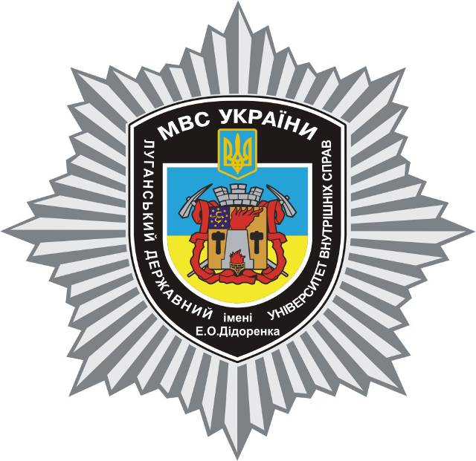

E.O. DIDORENKO
lUhANSK STATE UNIVERSITY
OF INTERNAL AFFAIRS

www.lduvs.edu.ua
www.facebook.com/lduvs



Petro Mohyla
Black Sea State University

www.chdu.edu.ua

Dear Colleagues,
On May, 27, 2016 the E.O. Didorenko Luhansk State University of Internal Affaires (evacuated from Luhansk), Luhansk local branch of the NGO "Ukrainian Association of Criminal Law" together with the Law Faculty of Petro Mohyla Black Sea State University hold the scientific seminar on "Crime counteraction: legal and criminological aspects". Leading scientists in criminal law sphere, law enforcement officials, and judges are invited to take part in the seminar.
The professors, senior teachers, teachers, post-graduate students, law enforcement officials, judges as well as representatives of other state bodies are welcome to take part in the seminar.
The seminar starts on May, 27, 2016 at 11 a.m. in the room of Petro Mohyla Black Sea State University (10 68 Marines Str., Mykolaiv, Ukraine).
Registration of participants – 10 a.m. to 11 a.m.
Participants must submit their reports to the address ye,pysmenskyy@i.ua (in the subject of the letter it is necessary to sign your surname and your city); application form of the participant (with the name and surname, scientific degree, position, place of work, telephone number, etc.) must be added. Getting these materials will be confirmed.
The deadline is April, 18, 2016.

Requirements for reports
A report must not be more than 4 pages.
Text, made in Microsoft Word for Windows;
А-4 format; left, right, top, bottom margins should be 2 cm;
Times New Roman, 14 pt, interline interval – 1,5, indentation – 1 cm.
References should be given at the end of a text. In the text the references must be put in square brackets [2, с.110], where the number of a source in accordance with the sources list is on the first place, and pages referred on the second place.
In the text you should not use automatic references and automatic numeration of paragraphs, particularly in the sources list.
Materials which do not correspond to the requirements will not be considered. The patterns of application and abstracts are added.

Participation in seminar is for free. Reports of the participants of the seminar are to be published in the journal of the conference, which will be sent to the authors.

Coordinator:
+380506817621
Doctor of the Science of Law, assistant professor
Yevhen Pys'mens'kyy (ye.pysmenskyy@i.ua)

www.facebook.com/ye.pysmenskyy

