Tanamedrove demografiuli tendenciebis gavlena
turizmze
mamuka gogelia
baTumis SoTa rusTavelis saxelmwifo universiteti
turizmis fakulteti, asistent profesori
biznesis administrirebis doqtori

reziume
სემინარი ,,Tanamedrove demografiuli tendenciebis gavlena turimze" moicavs im ZiriTadi ekonomikuri, socialuri da gansakuTrebiT demografiuli maxasiaTeblebis ganxilvas romelic aisaxeba ekoturizmis ganviTarebis perspeqtivebze.
gansakuTrebuli yuradRebaa gamaxvilebuli imaze rom saqarTveloSi yalibdeba mosaxleobis gajansaRebis kompleqsuri sistema, romelic mTeli rigi aucilebeli RonisZiebebis ganxorelebas moicavs praqtikaSi, riTac xeli Seewyoba arsebuli socialur-demografiuli Tu ekonomikuri problemebis nawilobriv mogvarebas.
wamoweulia iseTi demografiuli faqtorebi romlebic emsaxurebian dargis adamianuri resursebis uzunvelyofis sakiTxebis gadaWras, aseve Tanamedrove demografiuli tendenciebi romelic cvlian turistuli produqtis Sinaarssa da mimarTulebas; turistuli motivaciis saxeebi da misi Semadgeneli nawilebi romlebic gamoiyeneba piradi moTxovnebis dasakmayofileblad, am poziciidan turisti, rogorc pirovneba da agenti, warmogvidgeba sabazro operaciebis monawilis rolSi, individualuri kiTxvarebiTa da SemoTavazebebiT. individualuri moTxovna turistul produqtze bevradaa damokidebuli mis xarisxsa da fasze;
Tanamedrove samyaroSi mimdinare demografiuli tendenciebi aiZulebs turizmis sferoSi moqmed ekonomikur agentebs, rom meti yuradReba miaqcion turistuli produqtis rekreaciul-gamajansaRebel da ekologiur elementebs.

saqarTveloSi, turizmis ganviTarebis perspeqtivebze saubrisas, saWiroa ganvixiloT Semdegi sakiTxebi: arsebobs Tu ara am teritoriaze turizmis ganviTarebisaTvis saWiro resursebi da arsebobs Tu ara Sesabamisi turistuli bazari, romelzec SeiZleba gasvla (gogelia 2010:42).
ai es sakvanZo sakiTxebia gasaazrebeli da Sesafasebeli sanam turizmis ganviTarebis tendenciebis analizs mivmarTavT. amasTan saWiroa adgilobrivi socialur-ekonomikuri da demografiuli garemo faqtorebis Sefaseba da maTi gavlena turizmze.
gardamaval periodSi dawyebulma saqarTvelos ekonomikis reformirebis rocesebma socialur-demografiuli garemos mniSvnelovani gauareseba da turizmis industriis ganviTarebaze uaryofiTi zegavlenis moxdena gamoiwvia.
saojaxo meurneobebis ekonomikuri problemebi mosaxleobis cxovrebis donis mkveTr Semcirebas asaxaven, rac ara mxolod mosaxleobis ekonomikuri SesaZleblobebiT, aramed sxva usiamovno movlenebis ganviTarebiTac aris ganpirobebuli, kerZod: Sobadobis Semcireba, Sromisunarianobis asakis Semcireba, sapensio asakis mosaxleobis raodenobis gazrda, zewola ekonomikurad aqtiuri mosaxleobis jgufebis warmomadgenlebze.
qvemoT warmodgenili cxrili 1. naTlad asaxavs am dinamikas - saxezea ekonomikurad aqtiuri mosaxleobis odenobis Semcireba. aseve monacemebi gviCvenebs Tu ramdenad gaizarda umuSevrobis done rac TaviTavad gulisxmobs dasaqmebulTa raodenobis Semcirebas.
cxrili 1.
ekonomikurad aqtiuri mosaxleoba 2014-2021 w.w.

 | 2014 | 2015 | 2016 | 2017 | 2018 | 2019 | 2020 | 2020 I | 2020 II | 2020 III | 2020 IV
samuSao Zala (aqtiuri mosaxleoba),aT.kaci | 1629.0 | 1675.6 | 1653.8 | 1641.4 | 1605.2 | 1572.8 | 1523.7 | 1523.7 | 1515.0 | 1526.9 | 1505.7
dasaqmebuli, aTkaci | 1255.0 | 1308.5 | 1294.5 | 1286.9 | 1296.2 | 1295.9 | 1241.8 | 1241.8 | 1237.6 | 1269.11 | 1197.9
umuSevari, aT. kaci | 374.0 | 367.2 | 359.2 | 354.5 | 309.0 | 276.9 | 281.9 | 282.6 | 277.4 | 259.8 | 307.8
umuSevrobis done, % | 23.0 | 21.9 | 21.7 | 21.6 | 19.2 | 17.6 | 18.5 | 18.3 | 18.3 | 17.0 | 20.4
wyaro: saqarTvelos statistikis erovnuli samsaxuri, 2021.

dReisaTvis msoflio globaluri problemis kovid-19 pandemiis pirobebSi misi gavlena saqarTvelos mTavar ekonomikur maCveneblebZe aseTia: mSp - erT sul mosaxleze 2020 wlis maCveneblebiT kvartlebis mixedviT Cans Tu ramdenad didi dartyma iyo da aris pandemiis procesebi ekonomikis ganviTarebisaTvis.

mSp - erT sul mosaxleze
wlebi | 2017 | 2018 | 2019 | 1-2020 | 2-2020 | 3-2020 | 4-2020 | 2020
mSp-s realuri zrda procentebSi | 4.8 | 4.8 | 5.0 | 2.3 | -13.2 | -5.6 | -6.8 | 6.2
wyaro: saqarTvelos statistikis erovnuli samsaxuri 2021

rac Seexeba umuSevrobis done 20%, xolo inflaciis done 7,2%, es maCveneblebi migvaniSnebs Tu ramdenad didi da globaluri problemis winaSe vdgavarT da ramdenad mniSvnelovania swori strategiis SemuSaveba ekonomikur dargTa erTiani kompleqsuri ganviTarebis strategiis midgomiT da rac metad mniSvnelovania turizmis biznesis pirdapiri mniSvnelobiT gadawyoba da morgeba pandemiis regulaciebze.
movergoT pandemiis regulaciebs da Tan vmarToT qveyanaSi arsebuli sxva socialur demografiuli problemebi mTelim rigi kompleqsuri RonisZiebebis gatarebas moiTxovs saxelmwifos mier maregulirebeli politikisa da kerZo seqtoris erToblivi ZalisxmeviT.
saqarTveloSi demografiuli situaciis modifikaciis arsebuli tendenciebi moiTxoven aucilebel Carevasa da saswrafo zomebis miRebas, romle- bic mimarTuli iqnebian ara marto turizmis industriis sistemis ganmtkice bisaken, aramed regionis garemo pirobebis xarisxisa da am problemebis Tanamdevi pragmatuli amocanebis gadawyvetisaken. es ukanaskneli ukavSirdeba samkurnalo-profilaqtikuri da sportul-gamajansaRebeli RonisZiebebis gatarebas qveynis sanatoriul-sakurorto zonebSi. unda aRdges xelovnurad Sewyvetili samedicino-gamajansaRebeli teqnologiebis erTianoba da unda Seiqmnas dasasvenebeli kompleqsis marTvis erTiani sistema.
amJamad saqarTveloSi yalibdeba mosaxleobis gajansaRebis kompleqsuri
sistema, romelmac unda moicvas:
- teritoriebis ekologiuri mdgomareobis gaumjobeseba, im saxsrebis gamoyenebiT, romlebic mimarTulni iqnebian samrewvelo warmoebis ekologiizaciisaken;
- mosaxleobis keTildReobis donis amaRleba Sromis anazRaurebis amaR- lebis xarjze da pensionerebisa da bevri sxva naklebad uzrunveyofili jgufebis socialuri uzrunvelyofa;
- jandacvis sistemis srulyofa da profilaqtikuri RonisZiebebisgatareba gamovlenili daavadebebis winaaRmdeg;
- sakurorto-gamajansaRebeli, turistuli da sportuli organizaciebis socialuri garantiebisa da socialuri dacvis erTian sistemaSi CarTva;
- regionuli struqturebis gaZliereba. jandacvis ganviTarebis da sportul-gamajansaRebeli RonisZiebebis Catareba turizmis egidiT.
socialuri gagebiT SeiZleba aRmovaCinoT pirdapiri kavSiri mosaxleo- basa da maTi janmrTelobis SenarCunebis pirobebs Soris. rogorc vxedavT, aq aucileblad gavdivarT turizmis ganviTarebis aucileblobaze, rogorc saq- mianobis gansakuTrebul sferoze, romelsac SeuZlia xeli Seuwyos janmrTe- lobis dacvasa da sxva socialur-ekonomikuri problemebis gadawyvetas.
sawyis etapze SeiZleba arc ki arsebobdes pirdapiri kavSiri turizmis ganviTarebasa da axali adgilebis aTvisebas Soris. Tumca, Tu daveyrdnobiT adamianTa kanonier uflebas dasvenebasa da fasian Svebulebaze, migrantebi warmoadgenen qveynis demografiuli fondis mudmiv Semavsebel bloks.
diagrama 1.
migraciuli saldo (aTasi kaci).
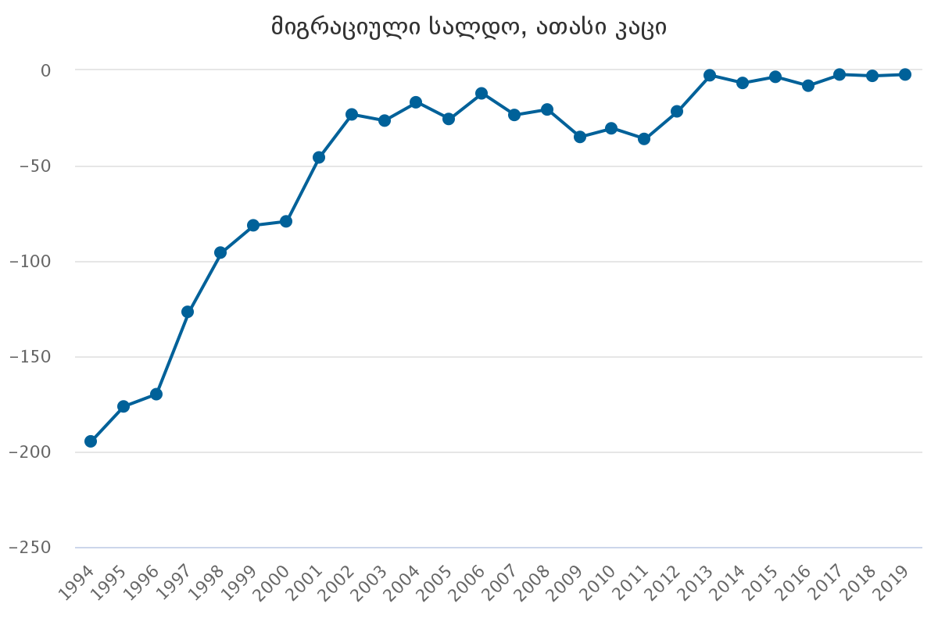
wyaro: saqarTvelos statistikis erovnuli samsaxuri, 2021

mosaxleobis keTildReobis saerTo donis amaRleba, mosaxleobis eko- nomikurad aqtiuri nawilis Sevseba sxva qveynis migrantebiT da sxva faqtore- biT, mosaxleobis turizmSi mzardi CarTulobis maCveneblad SeiZleba miviC- nioT. turizmis potenciur monawileebad SeiZleba CaiTvalos mosaxleobis SedarebiT uzrunvelyofili fena, e.w ,,saSualo fena“. saqarTveloSi saSualo fenis formirebis potenciuri baza didia, magram mTavar damabrkolebel faq- tors warmoadgens mosaxleobis arc ise maRali Semosavali, ekonomikuri dar- gebisa da regionebis krizisi. saqarTveloSi saSualo klasis formirebisa da turistuli momsaxurebis gamoyenebis sferoebis gafarToebisTvis turizmi metad Sesaferis sferos warmoadgens. turizmis ganviTarebis erT-erTi ten- denciaa turistebis ricxvis zrdac (xandazmuli adamianebis xarjze).
turistul momsaxurebaze moTxovnilebebis gazrdis erT-erT ganmsazRvrel pirobas qcevis motivacia da am moTxovnebis dakmayofilebis xerxebi warmoadgens.
turistebis qcevis motivaciis Seswavlam safuZveli daudo sxva sistemebis gamoyofasac. cnobilia motivaciis 7 mTavari (ZiriTadi) elementi (geldneri ...2013:239-255):
- mogzauroba - rogorc reaqcia survilis arqonaze. survili - gamoscado raRac araCveulebrivi, romelic gansxvavdeba misi Cveulebrivi garemosgan;
- ltolva romelime regionisa an qveynisaken, rogorc reaqcia mogzaurobis mimarTulebis motivaciaze;
- motivacia - rogorc fantazia. mogzaurobis SerCeva qmedebis ganxor- cielebis mizniT, romelic turistis TvalTaxedviT gansxvavdeba misi Cveulebrivi garemosagan;
- motivacia, rogorc klasifikaciuri mizani - mogzaurobis motivebis farTo krebulidan miznis amorCeva - megobrebis, mSoblebis monaxuleba, dasveneba, ganaTlebis gaRrmaveba;
- motivirebuli tipologia - dasasveneblad xelsayreli pirobebis moZebna. gamoviCinoT cnobismoyvareoba yvelaferi axlisa da ucnobis mimarT;
- turistis motivacia da codna - misi gacnobierebis saimedooba;
- motivacia, rogorc turistis mier sakuTari mdgomareobis TviTgamorkveva.
es Sefasebebi saSualebas iZleva davaskvnaT, rom motivaciis saxeebi da misi Semadgeneli nawilebi gamoiyeneba piradi moTxovnebis dasakmayofileblad. am poziciidan turisti, rogorc pirovneba da agenti, warmogvidgeba sabazro operaciebis monawilisrolSi, individualuri kiTxvarebiTa da Semo- TavazebiT. individualuri moTxovna turistul produqtze bevradaa damo- kidebuli mis xarisxsa da fasze. am kategoriebis ukan ukve sxva - raodenobrivi da xarisxobrivi maxasiaTeblebi dganan (Романова 1996:89). es maxasiaTeblebi msoflios bevr qveyanaSi biznes turizmis ganviTarebis ZiriTad pirobad rCeba:
- Tavisufali drois gamoyeneba gamajansaRebeli, dasvenebisa da kulturuli miznebisaTvis;
- biznesis ganviTarebisaTvis molaparakebebsa da sxva saqmian urTierTobebSi monawileoba;
- sanatoriul-kurortuli mkurnalobis Catareba, ojaxuri da sxvadasxva problemebis mogvareba, garemo xarisxis gaumjobesebis gaTvaliswinebiT.

daskvna:
- demografiuli komponenti turizmis dargis erT-erTi umniSvnelovanesi elementia, radgan igi zemoqmedebs turistuli produqtis bazris rogorc moTxovnis, ise miwodebis mxareze;
- demografiuli procesebi erTi mxriv, emsaxurebian dargis adamianuri resursebiT uzrunvelyofis sakiTxis gadaWras, meore mxriv, Tanamedrove demografiuli tendenciebi cvlian turistuli produqtis Si- naarssa da mimarTulebas;
- motivaciis saxeebi da misi Semadgeneli nawilebi gamoiyeneba piradi moTxovnebis dasakmayofileblad. am poziciidan turisti, rogorc pi- rovneba da agenti, warmogvidgeba sabazro operaciebis monawilis rol- Si, individualuri kiTxvarebiTa da SemoTavazebiT. individualuri moTxovna turistul produqtze bevradaa damokidebuli mis xarisxsa da fasze;
- Tanamedrove samyaroSi mimdinare demografiuli tendenciebi aiZulebs turizmis sferoSi moqmed ekonomikur agentebs meti yuradReba miaqcion turistuli produqtis rekreaciul-gamajansaRebel da ekologiur elementebi.

Influence of modern demographic trends on tourism
Rezume

Mamuka Gogelia
Batumi Shota Rustaveli State University
Faculty of Tourism, Assistant Professor
Doctor of Business Administration

The scientific article "Impact of modern demographic trends on tourism" deals with the discussion of the main economic, social and especially demographic characteristics that affect the prospects for the development of ecotourism.
A special attention is paid to the fact, that a comprehensive system of population health improvement is being formed in Georgia. It includes the practical implementation of a number of necessary measures that contribute to a partial solution of existing socio-demographic or economic problems.
In the foreground there are such demographic factors that serve to address the issues of providing human resources in this area, as well as modern demographic trends that change the content and direction of the tourist product. The types of tourist motivation and its components, used to meet personal needs, are also considered in the article. From this position, the tourist, as a person and an agent, is presented to us as a participant in market operations, with individual questionnaires and offers. Individual demand for a tourist product largely depends on its quality and price. Modern demographic trends in the modern world force economic agents, working in the field of tourism, to pay more attention to the recreational, health and eological elements of the tourism product.

gamoyenebuli literatura:
- mamuka gogelia – ,,ekologiuri turizmis strategiebis formireba”, baTumi 2013 weli;
- mamuka gogelia, ,,turizmis ganviTarebis perspeqtivebi saqarTveloSi“, I saerTaSoriso samecniero-praqtikuli konferencia ,,turizmi: ekonomika da biznesi“, SoTa rusTavelis saxelmwifo universiteti, turizmis fakulteti, aWaris a.r. turizmisa da kurortebis departamenti, Savi zRvis teqnikuri universiteti, 5-6 ivnisi, baTumi, 2010 წ;
- paata Caganava - ,,turizmis politika”, Tbilisi 2012 weli;
- Carlz r. geldneri; j.r. brent riTCi, ,,turizmi - safuZvlebi - praqtika - Teoria, gamomcemloba ,,baTumis SoTa rusTavelis saxelmwifo universiteti“, saqarTvelo, 2013 weli;
- Романова А.Н., ,, Маркетинг“, Учебник. М.: банки и биржи. Изд. объед, Юнити, 1996.

