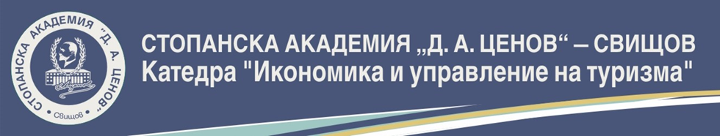
D. A. TSENOV ACADEMY OF ECONOMICS – SVISHTOV
DEPARTMENT OF ECONOMICS AND MANAGEMENT OF TOURISM

APPLICATION FORM

for participation in the scientific and practical conference on:

Tourism in the New Millennium - State and Prospects

to be held in Svishtov, 11-12 October 2019

dedicated to the 10th anniversary of
Economics of Tourism specialty
at D.A.Tsenov Academy of Economics – Svishtov

organised by
The Department of Economics and Management of Tourism
at D.A.Tsenov Academy of Economics – Svishtov

First name and surname of author: …………………………………………………………….
Academic rank and degree: …………………………………………………….
Organisation: …………………………………………………………………………………..

Postal address, e-mail, phone: …..……………………………………………………….
…………………………………………………………………………………………………..
…………………………………………………………………………………………………..
Research area:
…………………………………………………………………………...........................
Participation:
- With paper

When presenting the conference paper, I will use:
multimedia
other ……………………………………..………………………………
- In conference sessions, without paper

Title of paper …………………………………………………………………..
Abstract (max.10 lines) …………………………………………………………………….
………………………………………………………………………………………………………………………………………………………………………………………………………………………………………………………………………………………………………
- Attending the organised conference events on October 12th 2019 : yes no

