Dear colleagues!
Faculty of Law, Council of Young Scientists and administration of Ternopil National Economic University (TNEU) invite you to take part in the International Conference "Ukraine in conditions of reforming of legal system: modern realities and international experience" that will be held on 5- 6th of April, 2019 in TNEU.
Scientists, post-graduate students, lawyers-practitioners, representatives of research and design organizations and other institutions of Ukraine, whose activities are related to the topics of the conference, as well as scientists from Poland, Germany, Italy, Israel, Georgia, Armenia, Slovakia, Hungary, Bulgaria, The Republic of Estonia and other countries are invited to the conference.

The main conference topics are:
- Section 1. Theoretical, historical and legal bases of a state formation.
- Section 2. Public legal basis for the protection of human rights.
- Section 3. Private legal basis for the realization of human rights.
- Section 4. Latest trends and global challenges in the development of international relations and international law.
- Section 5. Organizational and legal aspects of ensuring economic security: current situation and prospects.
- Section 6. Psychological forms and concentrates of inter-subjective interaction in the social-legal field of Ukraine.
- Section 7. Historical, cultural and legal dimensions of modern information society.

Languages of the conference: Ukrainian, English, Polish, Russian.

For taking part in the conference you should sent on e-mail ufconference@ukr.net till March, 25, 2019:
  - an electronic version of the application form,
  - an electronic version of the report,
  - a copy of the proof of payment of the registration fee,
  - the scientific supervisor’s opinion (for postgraduate students).
Each participant will be awarded a special certificate in recognition of participation in the conference.

AN APPLICATOIN FORM
Name Surname
Position / academic title The course (a year of postgraduate studying) Themes of the report Section

Place of work / study
Information about the scientific supervisor:
Name
Surname
Position, scientific degree

Check-in information:
- Personal participation / I can not take part personally.
- Book / Do not book a hotel.

Contacts:
Index
Address
Tel.: Fax:
E-mail
Personal invitation should be sent in address:

REQUIREMENTS FOR ELECTRONIC VERSIONS OF REPORTS AND APPLICATIONS FOR PARTICIPANTS ARE:
- Please, send your attachments into separate files (application form, abstracts, review) and title them as shown below:
  - Ivanov_Ivan_application.rtf,
  - Ivanov_Ivan_report.rtf,
  - Ivanov_Ivan_opinion.pdf or Ivanov_Ivan_opinion.jpg,
- Text should be typed in Microsoft Word 6.0 and above for Windows, the file extension *.rtf is needed.
- Please, write “conference” in a subject of your e- mail.

Notes:
The materials of the reports are scheduled to be given before the conference and distributed free of charge to the participants who directly participated in it. If you can not attend the conference personally, we ask you to inform us about it in the application and to compensate for the additional expenses associated with sending the conference collection.

REQUIREMENTS FOR FORMATION OF
THE REPORTS
- Volume - 4 pages in A4 format page (297*210 mm), orientation - portrait;
- Margins: top, bottom, right, left - 20 mm;
- Font - Times New Roman, pins - 14, line spacing - 1.5, Style - Normal;
- References should be made in square brackets; list of references is noted at the end of the text without repetitions (eg. [2, 35]: 2 – is a number of the source and 35 – is a number of the page);
- First line - (font bold italics, aligned on the right side), name and surname of the author;
- Second line - (italic type, the way to the right) scientific degree, position / year of the study and university (double paragraph);
- Next paragraph - (all lowercase bold font, centered) theme of the report;
- Text of the report;
- At the end of the text of the report – references.

THE EXAMPLE

Ivan Ivanov
Lecturer of the Department of constitutional, administrative and financial law Ternopil National Economic University
(1 interval)

MODERN PRAGMATICS AND VECTORS OF THE DEVELOPMENT IN THE CONTEXT OF THE STRENGTHENING OF LEGAL SUPPORT OF IT-ACTIVITY
(1 interval)
In the terms of economic turbulence processes can not be left without attention problems ...
(1 interval)
REFERENCES:
- Trends of the shadow economy in Ukraine (2015) [electronic resource]. - Access: http://www.me.gov.ua/13300_2015.doc

Editorial board keeps the right to edit, shorten or reject the author’s materials.

GEOGRAPHICAL LOCATION

All major activities of the conference will be held in the building of the Faculty of Law, Ternopil National Economic University located in Ternopil, Mykulynetska Street, 46a.

How to get to the Faculty of Law, TNEU
Bus Stop "VATRA Corporation"
  - bus № 5, 5a, 8, 18
If you would like to meet you personally, Organizing Committee asks you to inform no later than 7 days before the conference about the date and time of your visit, and you should specify the vehicle type (train, bus) and the station of your arrival.

N.B. In case of any reasons making your presence in the conference impossible, please, inform the Organizing Committee in advance.
CONTACTS OF THE ORGANIZING COMMITTEE

46004, Ternopil,
Mykulynetska Street, 46a
(the Faculty of Law, Ternopil National Economic University)
E-mail: ufconference@ukr.net

Valentyna Sloma
+ 3 8(067) 94 53 210
Natalia Chudyk
+ 3 8(050) 52 11 361
Ministry of Education and Science of Ukraine

Ternopil National Economic University
Faculty of Law
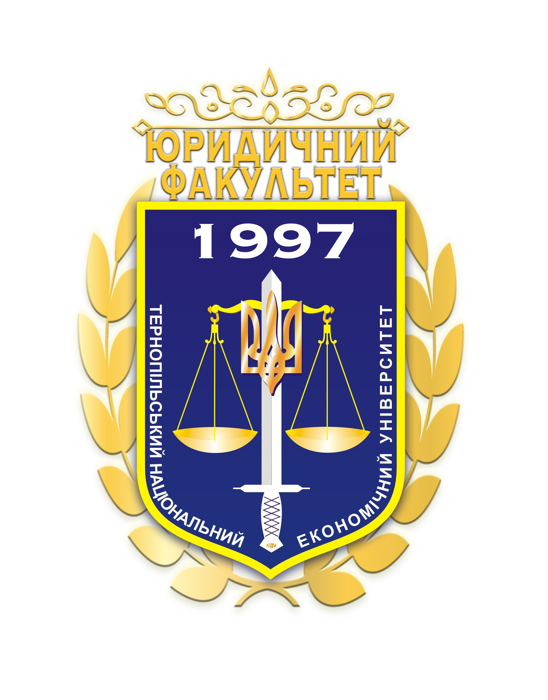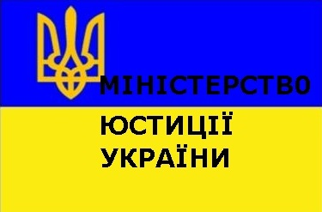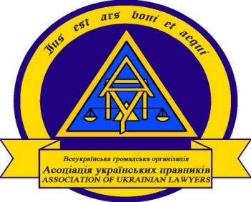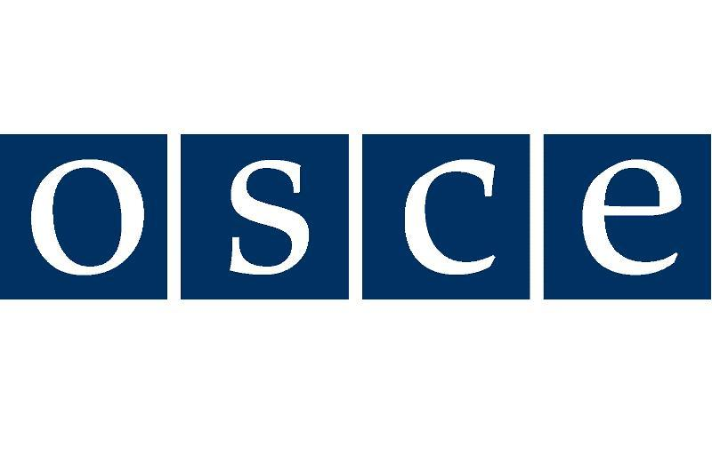
Ministry of Justice of Ukraine Association of Ukrainian Lawyers
Organization for Security and Cooperation
in Europe
Office of the Ukrainian Parliament Commissioner for Human Rights
Organization for Security and Cooperation
in Europe
European law faculties association
Council of Advocates of Ternopil region
Batumi Shota Rustaveli State University (Georgia)
Pontifical Gregorian University
(Italy)
University of Warmia and Mazury in Olsztyn (Poland)
ІV International conference
“Ukraine in conditions of reforming of legal system: modern realities and international experience”

5-6th of April, 2019
Ternopil

