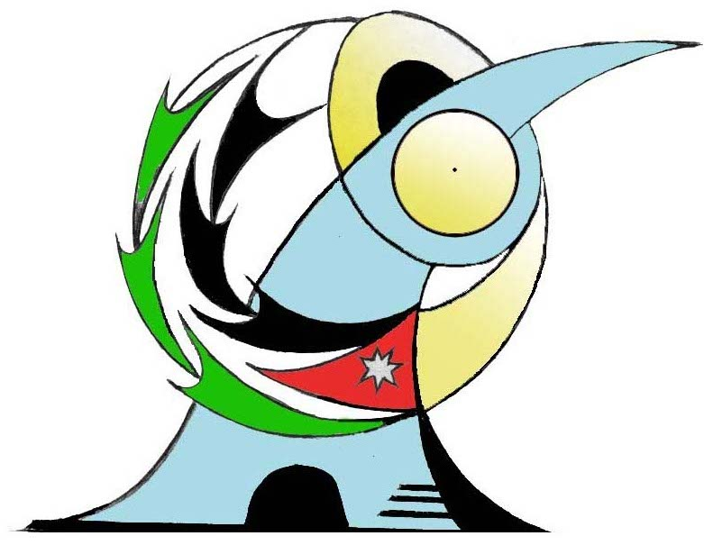

The Hashemite kingdom of Jordan
Ministry of Cultural
Northern Jordan Association for Multiculturalism

الممــلكــــة الأردنية الهاشميـــــة
وزارة الثقـــــافــــة
جمعية شمــال الأردن لتعدد الثقافات

1 / 6 / 200 DATE: 24 / 6 / 2018

Conditions for participation in the
conference for development and development

The role of educational institutions, municipalities, ministries, and civil society organizations
In human, social and economic development

Arrival on Saturday 22/9/2018 and departure on 29/9/2018
Sleep in a hotel two people in each room
We cover two meals a day
We cover internal mobility
Each participant is given a certificate with the conference bag
For those who wish to submit a working paper
The research should be submitted in Arabic or English with the need to check it linguistically.
The search should not exceed (15) pages A4 size
The researcher should identify the axis in which he writes and is accompanied by the research biography
Send the search by e-mail in Word format to the correspondence committee
Participation fee per person $ 1000 including everything with travel except ticket
. Fees are payable upon arrival
. The deadline for confirmation is 30/8/2018

With our utmost respect and appreciation

Executive Director of the Conference
Dr. Hayam Al-Jasim -
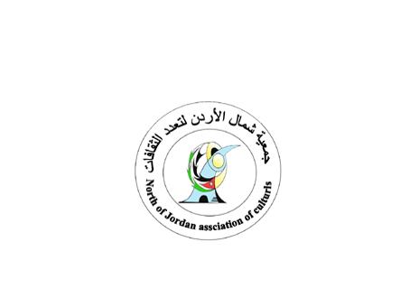
Hayaam

Jordan / Irbid : Email : , Jobajes@yahoo.com
TEL: FAX 00962 (27383373) MOBIL ; 00962 (788066169)
P. Box / 3660 / 21110

